CHECKPOINT MATHS, MOD 1

Put a ring around all the numbers that are exactly divisible by 9

3 56 72 93 146 198

[1]

- Jamie has 60 counters.

He gives
1 of his counters to Sam and
3
1 to Sally.
4

How many counters does Jamie have left?

3 Erik makes a sequence of patterns using tiles.
He records how many tiles are used for each pattern number.
[2]

Pattern number (p) | 1 | 2 | 3 | 4 | 5
Number of tiles (t) | 1 | 8 | 15 | 22 |  |  | 50

Complete the table. [2]

- Erik finds a rule connecting the pattern number and the number of tiles. Put a ring around the correct rule.

t = p + 7 t = 6p – 1 t = 7p + 1 t = 7p – 6 [1]

4 Write down the value of 196

5 (a) Work out the value of a.
[1]

a°

NOT TO SCALE

62°
49°

a = ° [1]

(b) Give a geometric reason for your answer.

[1]

6 Work out the temperature after each of these changes.

(a) The temperature starts at 6 °C and it falls by 13 °C. °C [1]

(b) The temperature starts at −2 °C and it falls by 8 °C. °C [1]

7 Martin is playing a game.
The probability of winning is 0.3

What is the probability of not winning?

[1]

8 Three students took a test.
The test was out of 50 marks.

David scored
38 marks
John scored half marks
Susan scored
72%

Who scored the highest?

Show your working.

................. scored the highest

[2]

9 Match each calculation with its answer.
0.7 × 1000 | 7
 | 70
70 × 0.1 | 700
 | 7000
700 ÷ 0.01 | 70 000

[1]

10 This table shows some outcomes from the function x → 2x + 3
input | output
1 | 5
6
9
15 | 33

Complete the output column of the table.

[1]

11 Look at the following equation.

45.6 ÷ 1.2 = 38

Use this information to write down the answers to the following.

(a) 456 ÷ 12 = [1] (b) 38 × 1.2 = [1] (c) 3.8 × 1.2 = [1]

12 A cuboid has dimensions 2 cm × 3 cm × 5 cm.
Part of the net of this cuboid is shown on the centimetre square grid. Complete the net of the cuboid.

[1]

13 The travel graph shows Karen’s journey between two towns, Springton and Watworth.

200

150
Distance travelled

(km)

100

50

0
09 00

10 00 11 00 12 00
Time

13 00 14 00

George makes the same journey between Springton and Watworth.
He leaves Springton at 10 00 and travels at a constant speed of 80 km/h without stopping.

(a) Draw a line on the travel graph to represent George’s journey. [1]

(b) How much earlier than Karen did George arrive at Watworth?

[1]

14 Write these numbers in order of size starting with the smallest.

25 32 3 64 0.22

smallest largest [1]

15 Work out

(a) 1.56 × 3.6

(b) 5.44 ÷ 1.6
[2]

[2]

16 Ayako and Joshua have a total of 59 sweets between them.
Ayako has n sweets.
Joshua has 3 fewer sweets than Ayako. Work out the value of n.

n = [2]

17 The map shows the positions of two beaches, A and B.

N N

sea

B

A
land

A boat is on a bearing of 062° from beach A and on a bearing of 286° from beach B.

Mark the position of the boat clearly on the map. [2]

18 Decide whether each of these statements is true or false.
Tick (9) the correct boxes.

90 = 0

93 × 92 = 95
True False

98 ÷ 94 = 92 [1]

19 Calculate

(a)
2 2 – 1 3
3 4

[2]

(b)
1 1 × 2 2
3 5

[2]

20 The map shows an island with two towns, P and Q.
The scale of the map is 1 cm : 4 km.

Q

P

Scale 1 cm : 4 km

The fire department wants to build a new fire station on the island. The fire station should be
• no more than 20 km from town P
• no more than 32 km from town Q.

Shade the region on the island where the fire station could be built. [2]

21 Work out

(a) 5 + 2 × 7

[1]

(b) 4 × (1 + 32)

[1]

22 Here is a number line.

–4 –3 –2 –1 0 1 2 3 4 5 6

Tick (3) which of these inequalities is shown on the number line.

–2 ≤ n ≤ 5

–2 < n ≤ 5

–2 ≤ n < 5

5 ≥ n < –2 [1]

23 The stem and leaf diagram shows the heights, in cm, of the 15 students in class 8A and the 15 students in class 8B.

Class 8A Class 8B

8 3 1 14 6

7 7 7 5 15 0 2 7

9 9 8 6 4 16 1 1 3 5 8

3 1 0 17 0 4 6 6 6

18 2

Key: 14 | 6 = 146 cm
1| 14 = 141 cm

(a) Find the range of heights of the students in class 8A.

(b) Find the median of the heights of the students in class 8B.
cm [1]

cm [1]

(c) Give two statements to compare the heights of the students in the two classes.

[2]

24 Ahmed buys a pack of 20 drinks to sell at the school shop.
The pack costs $5.
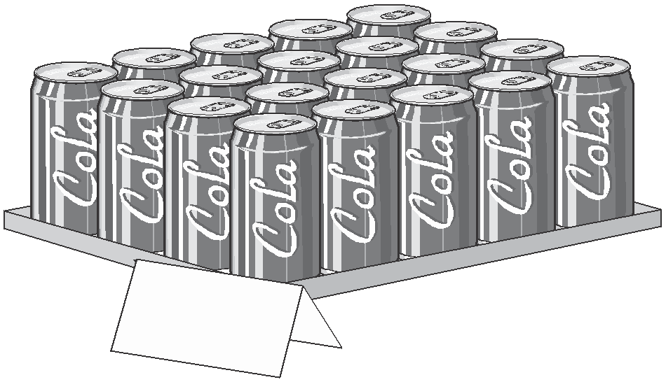He wants to make a 40% profit.

How much should he sell each drink for?

$ [3]

